
International School

Capstone Project 2
CMU-SE 451

Architecture Document
Version 2.5
Date: 24 Feb, 2022

Pet Care and Supervision Services

Submitted by

Truong Le Dai
Nguyen Hong Hieu
Tran Thi Chung
Le Quang Van

Approved by
Dr. Nguyen Tan Thuan

.

Proposal Review Panel Representative:

Name Signature Date

Capstone Project 2- Mentor:Dr. Nguyen Tan Thuan

Name Signature Date
PROJECT INFORMATION

Project acronym | PetCare
Project Title | Pet Care and Supervision Services
Start Date | 22 Feb 2022 | End Date | 24 Feb 2022
Lead Institution | International School, Duy Tan University
Project Mentor | Dr. Nguyen Tan Thuan
Scrum master / Project Leader & contact details | Truong Le Dai  Email:daicatimmai123v30@gmail.com  Tel: 0774443926
Partner Organization
Project Web URL
Team members | Name | Email |  | Tel
24211407122 | Truong Le Dai | daicatimmai123v30@gmail.com |  | 799400038
24211205523 | Nguyen Hong Hieu | nguyenhonghieuit@gmail.com |  | 777903474
24201402277 | Tran Thi Chung | tranchung10a3@gmail.com |  | 945228146
24211401402 | Le Quang Van | vanlequang00@gmail.com |  | 898163596

Architecture Document

Document Title | Architecture
Reporting Period | 24 Feb 2022
Author(s) & project | Truong Le Dai, Scrum Master
Role | Nguyen Hong Hieu | Member
 | Tran Thi Chung | Member
 | Le Quang Van | Member
Date | 24 Feb 2022 | Filename |  | C2SE.27-Architecture-PetCare.doc
URL
Access | Project and CMU Program

REVISION HISTORY

Version | Date | Comments | Author | Approval
1.0 | 22 Sept 2021 | Initial | C2SE.27 Team | Team
1.1 | 23 Sept 2021 | Create architectural drivers | C2SE.27 Team | Team
1.2 | 24 Sept 2021 | Create C&C diagram | C2SE.27 Team | Team
1.3 | 25 Sept 2021 | Create MVC diagram | C2SE.27 Team | Team
1.4 | 26 Sept 2021 | Create Sequence diagram | C2SE.27 Team | Team
1.5 | 27 Sept 2021 | Create allocation view | C2SE.27 Team | Team
2.0 | 22 Feb 2022 | Initial | C2SE.27 Team | Team
2.1 | 22 Feb 2022 | Create architectural drivers | C2SE.27 Team | Team
2.2 | 23 Feb 2022 | Create C&C diagram | C2SE.27 Team | Team
2.3 | 23 Feb 2022 | Create MVC diagram | C2SE.27 Team | Team
2.4 | 23 Feb 2022 | Create Sequence diagram | C2SE.27 Team | Team
2.5 | 24 Feb 2022 | Create allocation view | C2SE.27 Team | Team

DOCUMENT APPROVALS

The following signatures are required for approval of this document
Dr. Nguyen Tan Thuan  Mentor |  | Date:
Truong Le Dai  Scrum Master |  | Date:
Nguyen Hong Hieu  Product Owner |  | Date:
Tran Thi Chung  Member |  | Date:
Le Quang Van  Member |  | Date:

Table of Contents
1. Introduction 6
1.1. Project overview 6
1.2. Purpose 6
2. Architectural Drivers 7
2.1. Business constraints 7
2.2. Technical constraints 7
2.3. Functional requirements 8
2.4. Quality Attributes 8
3. Architecture Overview 12
3.1. Use Case Diagram 13
3.2. System context 14
3.3. Component and Connector 15
3.4. Sequence diagram 17
3.5. Module view 22
3.6. Allocation view 23
4. References 24

Introduction

Project overview
PetCare, which is named after the Greek goddess of animals, provides a communication channel between a veterinary facility and their customer, or owners of their patients. We realize the inefficiency in the traditional routines of the vets in Vietnam mainly caused by lack of understanding between related parties, for example: A vet can have many cases in a day which can be new or regular customers and a vet veterinarian usually has a hard time keeping check of every animal he first takes care of. And on the customer’s side there’s usually the lack of knowledge in animal physiology, which might cause confusion on whether to take their pet to the vet or not, especially in the time of a pandemic like COVID-19. The application will include a website and a mobile app. Our main target is creating a vet manager platform that can suit any vet’s way of working while creating an easy and useful communicating channel for the customers.

Purpose
This document provides a comprehensive architectural overview of the system, using a number of different architectural views to depict different aspects of the system. It is intended to capture and convey the significant architectural decisions which have been made on the system.
  - Business driver
Business Problems:
- The problems include the regulations of the customer vets. They may come in many sizes with different standards and rules so scalability is also prioritized as we want to reach out to as many buyers as possible. One of the solutions to this is offering different packs of features that fits better with different types of vet.
- Another technical problem is the constant data flow. Since it’s a communication channel at the heart, and the work it does involves scheduling medical examinations, storing medical profiles of patients and their owners, precision and consistency play an important role, as well as security.

Business Need:
The PetCare have specific uses:
- Helping pet owners to book a quick appointment to the vet in the most convenient way
- Make health care process for pets and animals can be as optimal as the state of the art veterinary allows
- Help pet owners can contact the veterinarian anytime, anywhere without going to the clinic
- Provide pet health reports based on charts and diagrams.
All the things above are based on the functionality of the PetCare Application system. It fully meets these requirements. Therefore, the development of PetCare is very necessary and meaningful. Especially during this difficult time of travel due to covid-19

Architectural Drivers

Business constraints
- Sources: 4 people.
- Project was started on: 14/02/2022.
- Project will be ended on: 15/05/2022.
- Project will be finished in 90 days (1440 hours).
- Cost: $2880.

Technical constraints
Technical to develop:
- Programming Language: HTML, CSS, JavaScript, C++
- Databases: MongoDB
- Version Control System: Github, Zalo, Drive, Trello
- Operating System: Windows, IOS
- Editor tool: Visual Studio Code
- Library/Framework: React JS, React Native

Server:
- Programming Language: JavaScript
- Framework: ExpressJS (NodeJS).
- Libraries: Node-Postgres.
- Operating System: Windows, Linux, MacOS.
- Network Accessing: World Wide Web (WWW), HTTP methods (POST, GET) via RESTful API
Client:
- Web Browser: Chrome, Firefox, Microsoft Edge, Coccoc
- Manage code version: GitHub.
- Net Framework 3.5 or higher.
- Network Accessing: World Wide Web (WWW), HTTP methods (POST, GET) via RESTful API

Functional requirements
- References to Product Backlog specification of ProductBacklogV1.1.docx

Quality Attributes
    - Utility
There are the following quality attributes that drive the design of architecture. Each quality attribute scenario is ranked with importance (I) defined by the Pet Owner, and the estimated level of difficulty (D). Both values are based on a scale of High (H) - Medium (M) - Low (L).

    - Quality attributes
      - Security
Scenario: When a pet owner or veterinarian want to registers, their password will be encrypted before being saved to database
Quality Attributes | Security
Stimulus | Register
Source of stimulus | Tourist
Environment | In runtime
Artifact stimulated | System
Response | Encrypt password
Response measure(s) | Encrypted through 3 layers of security

      - Performance
Scenario: Pet Owner searches for a list veterinarian while using the app. The system summarizes the list of veterinarian and response details for them in less than 4 seconds.
Quality Attributes | Performance
Stimulus | Search list of veterinarians
Source of stimulus | Pet Owner
Environment | In runtime
Artifact stimulated | Application
Response | Summarizes veterinarian details and response expected
Response measure(s) | Less than 4 seconds

      - Usability
Scenario: Pet Owners access the system by signing up for a new account or logging in with their Google account with the same email. The application allows access with this email account in both ways.
Quality Attributes | Usability
Stimulus | Access the system by signing up for a new account or logging in with their Google account with the same email
Source of stimulus | Pet Owner
Environment | In runtime
Artifact stimulated | Application
Response | Allows access with this email account
Response measure(s) | both ways

Scenario: Pet Owner book an appointment in PetCare. Unfortunately they are busy so they can also cancel the appointment with good reason.
Quality Attributes | Usability
Stimulus | Cancel Or Change Appointment time
Source of stimulus | Pet Owner
Environment | The system
Artifact stimulated | All devices
Response | See the message “cancel appointment successful”
Response measure(s) | Instantly

      - Availability
Scenario: In case of upgrade or maintenance, the maintenance process will be out of business hours.
Quality Attributes | Availability
Stimulus | Timing maintenance
Source of stimulus | Internal to the system
Environment | Normal operation
Artifact stimulated | The System
Response | Continue to operate in normal or degraded mode
Response measure(s) | Time interval when the system must be available

      - Correctness
Scenario: Scenario: When the pet owner performs operations with an appointment including modifying or canceling the tour, the veterinarian schedule will be updated correctly on the PetCare application.
Quality Attributes | Correctness
Stimulus | Performs operations with an appointment
Source of stimulus | Pet Owner
Environment | Runtime
Artifact stimulated | The System
Response | Performs operations with an appointment
Response measure(s) | The veterinarian schedule will be updated correctly on the PetCare application.

Modifiability
Scenario: Scenario: A product owner wants to develop additional features and construct a payment online for the next version. The system allows for an expansion within 3 months of effort without affecting existing functions
Quality Attributes | Modifiability
Stimulus | Develop additional features and construct a payment online
Source of stimulus | A product owner
Environment | The next version
Artifact stimulated | The system
Response | Allows for an expansion
Response measure(s) | 3 months of effort without affecting existing functions

Architecture Overview
This section shows the diagrams which bounds our target system and describes the architecture and interaction between components.

Use Case Diagram
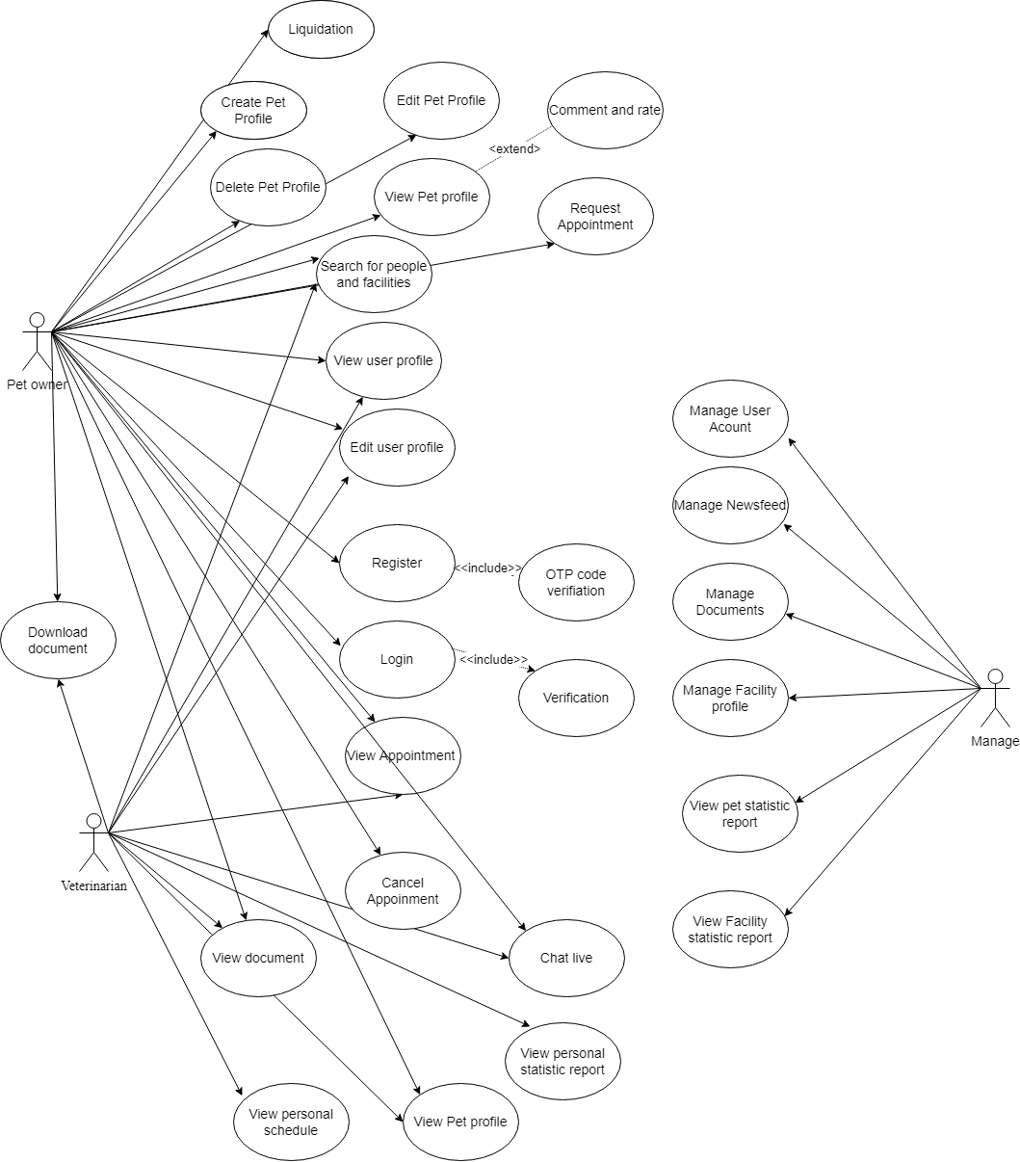

System context

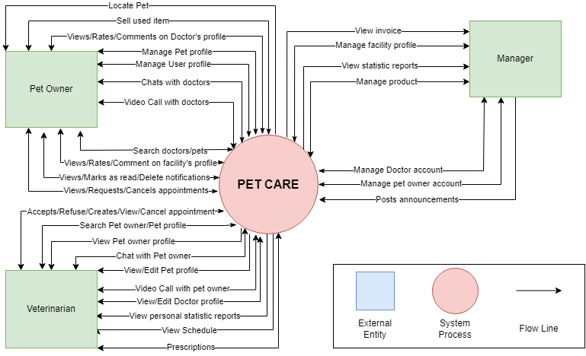
- Pet owner:
  - Creates a pet owner account.
  - Views/Edits user profile.
  - Creates/Views/Edits/Deletes pet profiles.
  - Searches pet/veterinarian/facilities profiles.
  - Starts live chats with veterinarians.
  - Views/Rates/Comments on veterinarian profiles.
  - Views/Rates/Comments on facility profiles.
  - Views/Requests/Cancels appointments.
  - Opens/Mark as read/Delete Notifications.
  - Views/Download the vet’s catalogs and documents.
  - Locate Pet: Pet owners can know where their pet is through the collar
  - Liquidation : Customer can liquidate pet products (post products)
  - Starts video call with veterinarian

- Veterinarian:
  - Views/Edits veterinarian profile.
  - Views pet owner profiles.
  - Starts live chats with pet owners.
  - Search pet owner/ pet.
  - Views/Edits pet profiles.
  - Accepts/Refuses appointment requests.
  - Create/Views/Cancels appointments.
  - Views/Adds to/Removes from pet list.
  - Views personal statistical reports.
  - Views schedule.
  - Start video call with pet owner/Veterinarian/manager
- Manager:
  - Creates/Edits/Views/Restrict/Deletes veterinarian and pet owner accounts.
  - Create/Edits/Views/Deletes facility profiles.
  - Views/Update statistical reports of veterinarians and facilities.
  - Views/Add/Removes catalogs and documents.
  - Video call with pet owner/Veterinarian/manager

Component and Connector
We mainly used a C&C view to argue and reason about architectural properties, quality attribute requirements, and functional requirements that the system must add here.
This view type partitions the system into components that have some runtime presence such as processes, objects, data stores, and connectors or that represent pathways of communication such as data flows and access to shared storage.
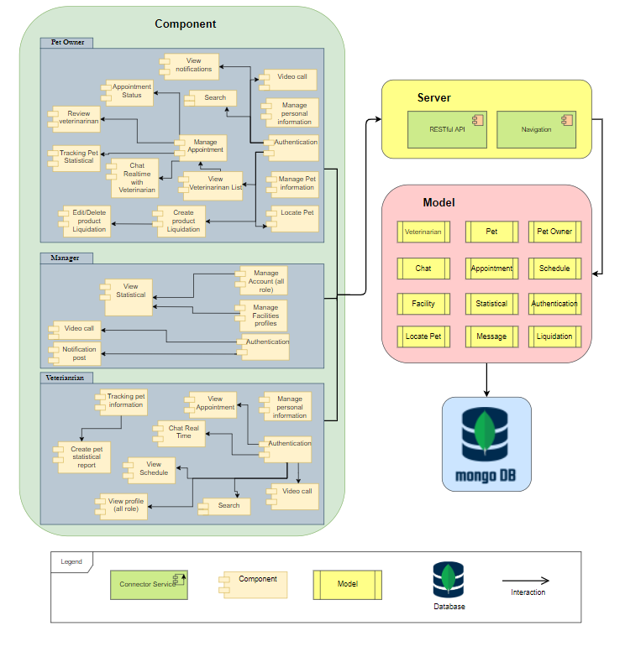
Figure 3.3.1: C&C View for PetCare

Prose
The web client sends and receives data from the server through the web service API. User operations will send requests to the server through the API, the server will process the data with the corresponding models and access the database to retrieve data, then respond to the information to the web and mobile client through the API to display it to the user
Role & Responsibility | Description
Component | The component includes 3 actor, including pet owner, veterinarian and admin When actors use the system, they need to pass the authenticate, after on, users can use the existing functions of the role that is logged on the system.
Service Bus
Navigation | Provides an easy to use navigation solution
Restful API | Provides a data in your API
Model | Set of functions and procedures that allow the creation of applications which access the features or data of an operating system, application, or other service.
Database | The place contains all data about veterinarian, pet, pet owner information

Sequence diagram
Sequence diagram is used to display the sequence of activities. Sequence diagrams show the workflow from a start point to the finish point detailing the many decision paths that exist in the progression of events contained in the activity.
    - Login
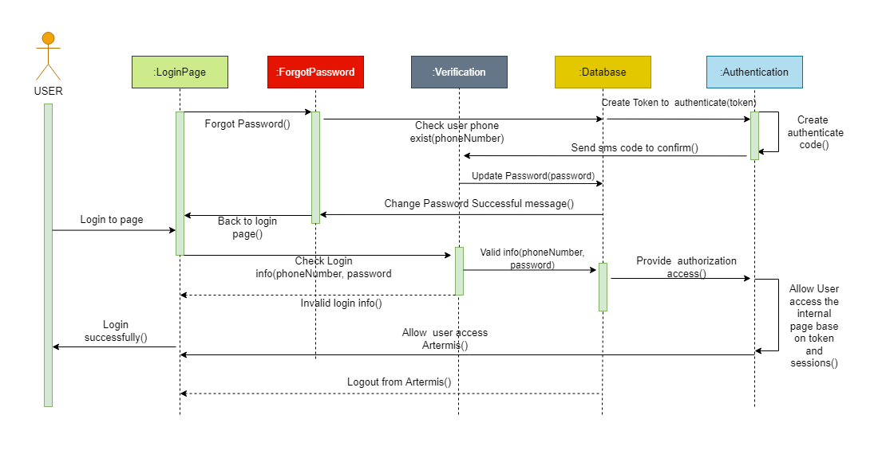
Figure 3.4.1.1: Sequence diagram for Login

    - Register
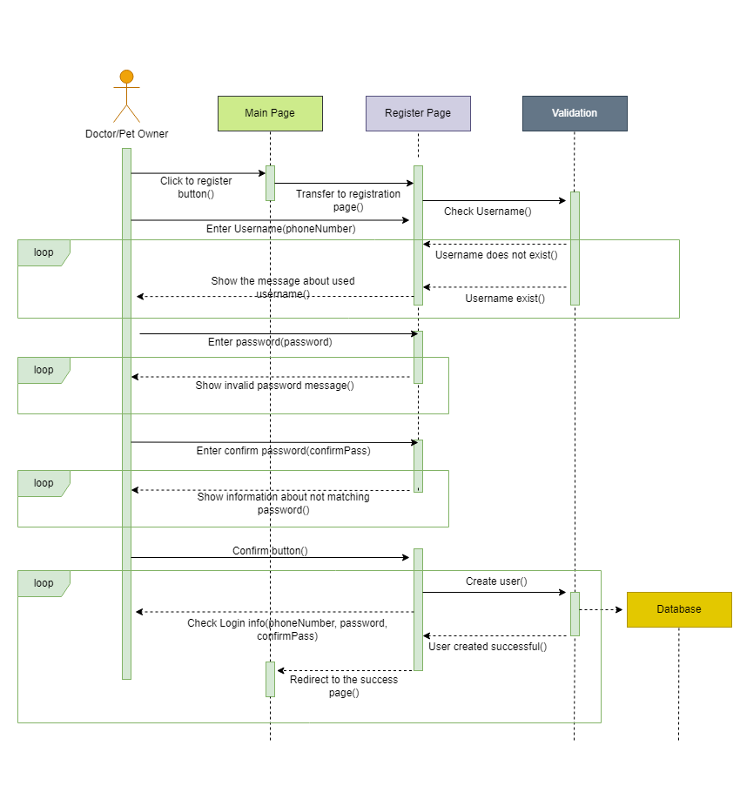

Figure 3.4.1.2: Sequence diagram for Register

    - Appointment
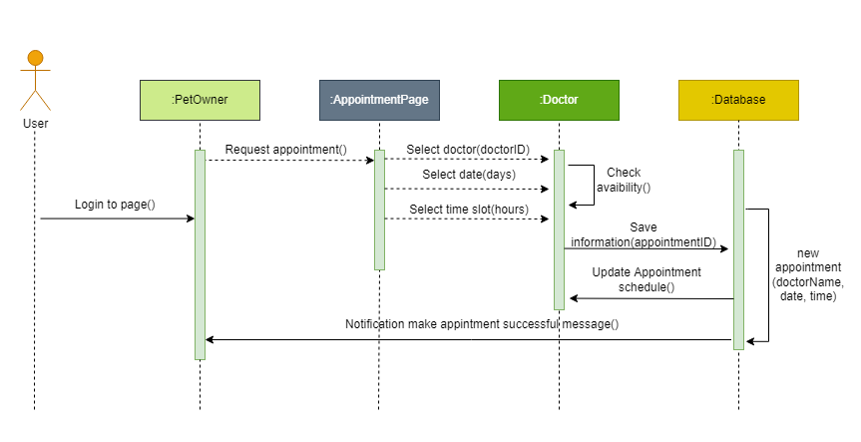
Figure 3.4.1.3: Sequence diagram for Appointment

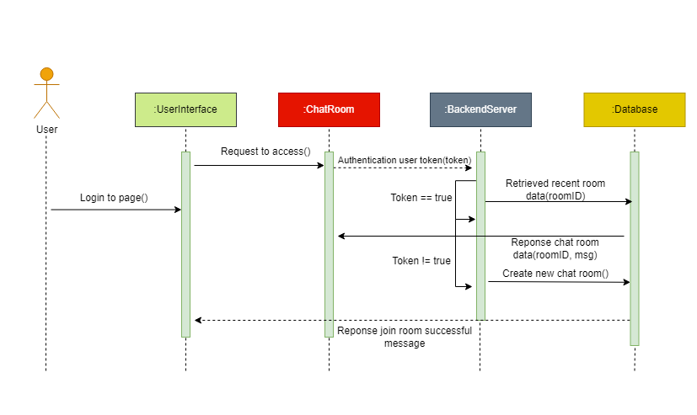
    - Chat realtime

Figure 3.4.4: Sequence diagram for Chat bot

Module view
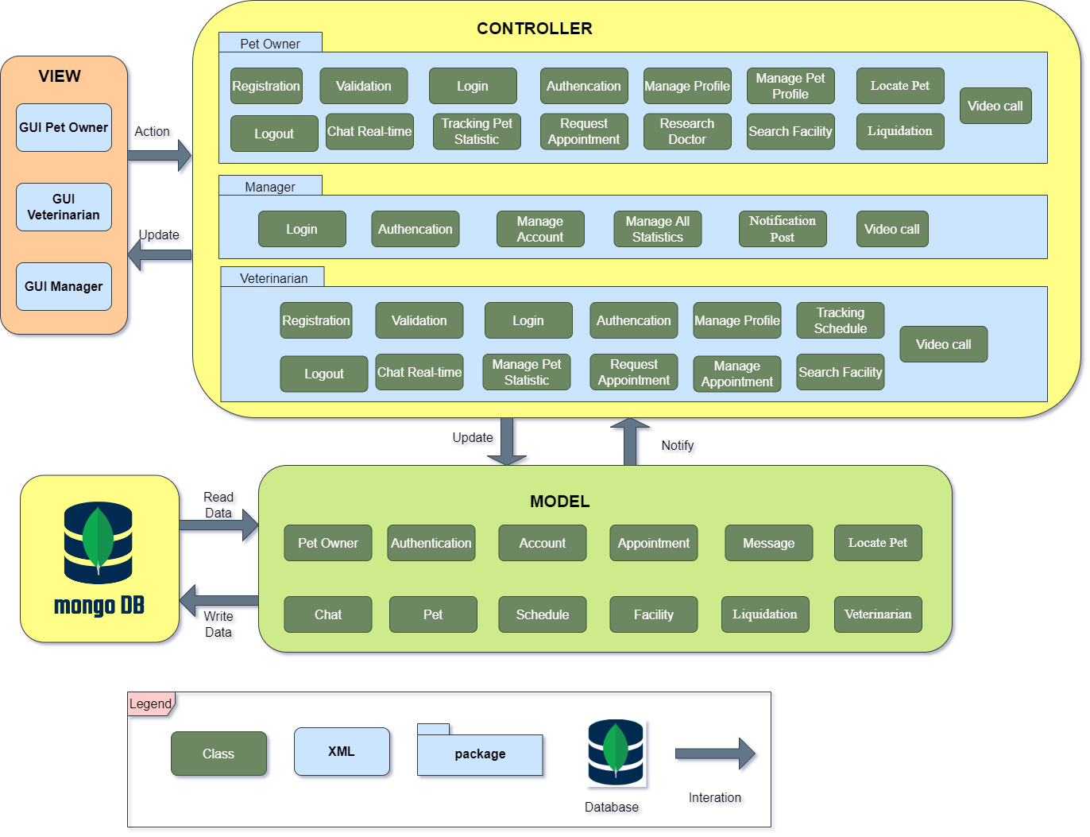
Figure 3.5.1: MVC Pattern for PetCare
Prose
Role & Responsibility | Description
Model | The model manages the data. Whether the data is from a database, API, or a JSON object, the model is responsible for managing it
View | The application package contains graphical user interface (GUI) for veterinarian, pet owner and administrator
Controller | The controller's responsibility is to pull, modify, and provide data to the user. The controller is the link between the view and model.
Database | The database aggregation operations process the data records/documents and return results..

Allocation view
The allocation view models the run-time architecture of a system. It shows the configuration of the hardware elements when the system is deployed.
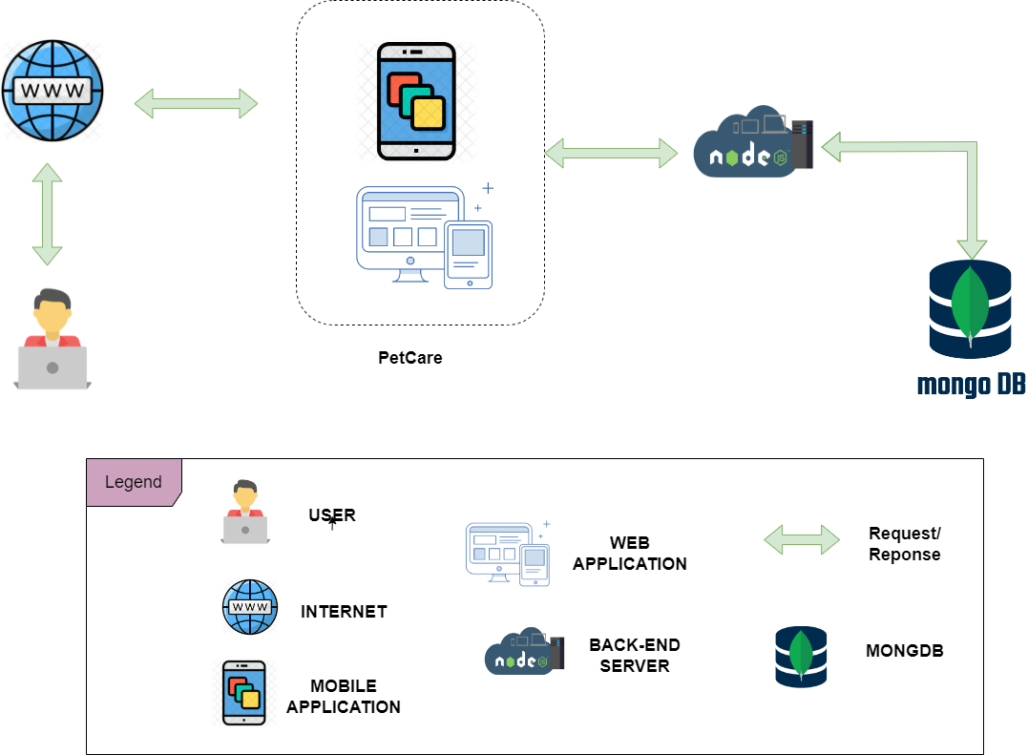
Figure 3.6.1: Allocation View for PetCare
Prose
Element | Responsibilities
User | User that interact with PetCare.
Mobile Application | Pet Owner use this device to install and use PetCare app
Web Application | Device running browser and helping Admin and veterinarian to use the functions of the website to manage more convenient.
Request/ Response | Get request metadata from client and response the data to client.
Backend Server | Provide an API to support the interaction between the user interface and the server. where to install and run the backend API
MongoDB | The place contains all data about veterinarian, pet, pet owner information

References
- Draw.io: https://www.draw.io
- Quality attributes measurements and implementation strategies: https://melsatar.blog/2017/08/27/quality-attributes-measurements-and-implementation-strategies/
- Understanding Quality Attributes: https://cs.unb.ca/~wdu/cs6075w10/sa2.htm
- MVC: https://vi.wikipedia.org/wiki/MVC
- The Model View Controller Pattern: https://freecodecamp.org/news/the-model-view-controller-pattern-mvc-architecture-and-frameworks-explained/
- Design Pattern: https://stdio.vn/software-architecture/design-pattern-mvc-pattern-VTnHy
- Driver Architecture: https://docs.microsoft.com/vi-vn/sql/odbc/reference/driver-architecture?view=sql-server-2016
- Component-and-Connector (C&C) Views: https://sites.google.com/site/softwarearchitectureinpractice/9-documenting-software-architecture/c-component-and-connector-c-c-views
- Vetup: https://en.vetup.com/
- FVET: https://tinhte.vn/thread/fvet-vietnam-ung-dung-di-dong-dau-tien-tai-viet-nam-giup-nguoi-chan-nuoi-hoi-ngay-bac-si-thu-y.2928816/?fbclid=IwAR0-Z3Ujo3z1v8V3u_Bo8O11T5Nu6fxIn9Xe4XUwcdvqlAFu8hiJs_73v1w
- Software Development Standards for the Guidance and Control Software Project https://sw-eng.larc.nasa.gov/
- Veterinarian: https://en.wikipedia.org/wiki/Veterinarian
- Software Development Standards for the Guidance and Control Software Project https://sw-eng.larc.nasa.gov/

